SilverScreen

Use-Case Specification: <Use-Case Name>Activate Account

Version 1.0

Revision History

|  |  |  |  |
| --- | --- | --- | --- |
| **Date** | **Version** | **Description** | **Author** |
| 28.10.2016 | 1.0 | Initial draft | Marcel Borrmann |
| 03.11.2016 | 1.1 | Corrected Diagramm | Fabian Blatz |
| 15.11.2016 | 1.2 | Added Narrative | Fabian Blatz |
| 25.04.2017 | 1.3 | Added Function Points | Marcel Borrmann |

Table of Contents

[1. Use-Case Name 4](#_Toc465673097)

[1.1 Brief Description 4](#_Toc465673098)

[2. Flow of Events 4](#_Toc465673099)

[2.1 Basic Flow 4](#_Toc465673100)

[2.2 Alternative Flows 4](#_Toc465673101)

[3. Special Requirements 4](#_Toc465673102)

[4. Preconditions 4](#_Toc465673103)

[5. Postconditions 4](#_Toc465673104)

[6. Extension Points 4](#_Toc465673105)

Use-Case Specification: <Use-Case Name>

# Use-Case Name

## Brief Description

After the user was sent an activation link he has to confirm his registration by clicking a link which will be embedded in the email.

# Flow of Events

## Basic Flow

C:\Users\Fabian\Documents\Github\TINF15B4-LSMF\docs\Use-Cases\03_Activate UC\UC_Acitvate.png

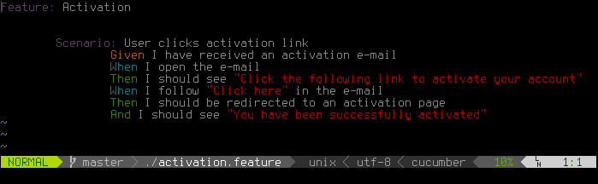

## Alternative Flows

#### None

# Special Requirements

The phone has an active internet connection

# Preconditions

The user received the email with the activation link.

# Postconditions

The user information in the DB is updated, the user is able to login.

# Extension Points

None

# Function Points

# 

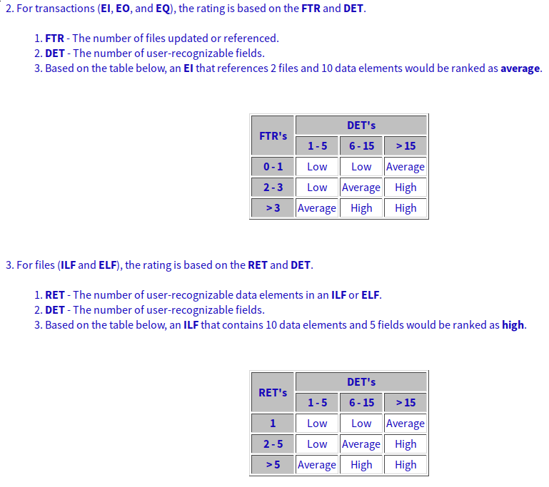RET/DET/FTR: [Here](http://i.imgur.com/vZ1JP73.png)